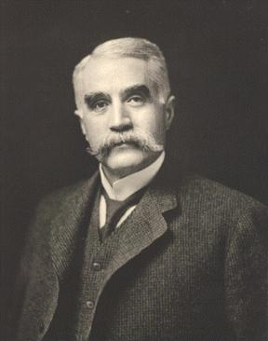

My name is Charles Brush.

I was born near Cleveland, Ohio.

I lived from 1849-1929

I invented a new way to chase away the darkness on roads.

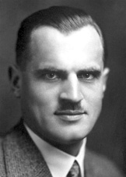

My name Arthur Compton.

I was born in Wooster, Ohio.

I lived from 1892-1962.

I invented a more modern way of seeing if bones are broken.

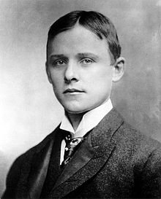

My name is Charles Hall.

I was born in Thompson, Ohio.

I lived from 1863-1914.

I invented an inexpensive way to produce something that is used in the kitchen to cover food.

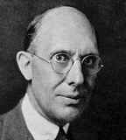

My name is Charles Kettering.

I was born in Loudonville, Ohio.

I lived from 1876-1958.

I invented something that replaced the crank an automobile.

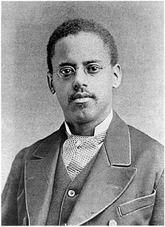

My name is Granville Woods.

I was born in Columbus, Ohio.

I lived from 1856-1910.

I invented many things that improved travel and safety on the machine that goes on tracks.

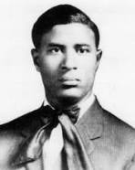

My name is Garrett Morgan.

I was born in Kentucky and moved to Cincinnati, Ohio when he was fifteen.

I lived from 1877-1963.

I invented something that made driving much safer.

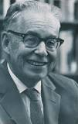

My name is Charles Richter.

I was born in Overpeck, Ohio.

I lived from 1900-1985.

I invented a way to rate the power of the shaking of the ground.

My name is Garrett Morgan.

I was born in Kentucky and moved to Cincinnati, Ohio when he was fifteen.

I lived from 1877-1963.

I invented something that made driving much safer.

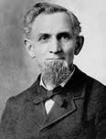

My name is James Spangler.

I am from Stark County, Ohio.

I lived from 1848-1915.

I invented an electrical device that cleans the carpet.

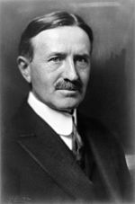

My name is Harvey Firestone.

I was born in Columbiana, Ohio.

I lived from 1868-1938.

I invented something that made cars ride smoother.

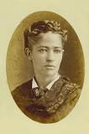

My name is Josephine Cochran.

I was born in Ashtabula County, Ohio.

I lived from 1839-1913.

I invented something used to make plates, bowls, and silverware clean.

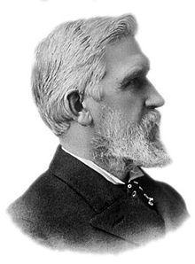

My name is Elisha Gray.

I was born in Barnesville, Ohio.

I lived from 1835-1901.

I invented improvements for sending messages through a wire.

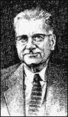

My name is Ernest Volwiler.

I was born in Hamilton, Ohio.

I lived from 1893-1992.

I invented something doctors use to help patients sleep during surgery.

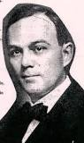

My name is W.F. Semple.

I am from Mount Vernon, Ohio.

I lived from 1866-1900.

I invented something that goes in your mouth but it is not food.

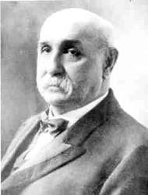

My name is James Ritty.

I am from Dayton, Ohio.

I lived from 1836-1918.

I invented something that is used in stores to keep track of the money.

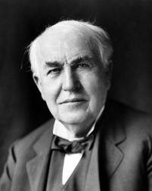

My name is Thomas Edison.

I was born in Milan, Ohio.

I lived from 1847-1931.

I invented many things but one of the things I invented was something that could record sound and play it back.

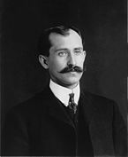 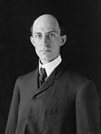

Our names are Orville and Wilbur Wright.

We are from Dayton, Ohio.

Orville lived from 1871-1948.

Wilbur lived from 1867-1912.

We most known for inventing the first successful trip with this vehicle.

|  |  |  |
| --- | --- | --- |
| 1 | 2 | 3 |
| 4 | 5 | 6 |
| 7 | 8 | 9 |
| 10 | 11 | 12 |
| 13 | 14 | 15 |
| 16 |  |  |